ABN:260 273 84 714 224
224 Timor St; Warrnambool 3280
5562 1109
www.thefproject.org.au
Instagram: thefprojectarts
Facebook.com/thefprojectarts

EXHIBITION APPLICATION

The F Project Art Gallery is now accepting exhibition proposals for solo and group shows from emerging and also experienced artists.
We encourage applications from artists of various backgrounds, disciplines and stages of career.

Exhibitions are for four weeks, unless by prior arrangement, which includes install on the Monday and Tuesday of the first week and bump-out on the last day or by arrangement with the artist/s.
Costs
$600 for a four week exhibition for F Project Members; $800 for a four week exhibition for non F Project Members.
This fee includes:
- Volunteer gallery and retail shop staff working Wednesday – Sunday, 10am – 4pm and during the exhibition opening
- Curatorial advice
- Installation assistance
- E-newsletter, social media and local radio slots and local newspaper articles where possible
- Handling of sales (commission is 20% of sales). From July 1 2023 the F Project will be registered for GST.
- Assistance with opening event
- Facilitation of artist talk during exhibition and or opportunity to run workshops in conjunction with the show if applicable (optional)
We require six weeks notice in the case of cancellation of an exhibition where possible.
We accept no responsibility for theft of art works or damage caused by Fire, Flood, storm or accident (utmost care will be undertaken by the volunteer staff to protect all art works at all time). Any insurance is the responsibility of the exhibitor.

Applications
To apply please provide the following and attach to this form:
- Name, address and contact details (email & phone number)
- The title or working title of the exhibition
- A written outline of your idea and themes and concepts behind your work (max 250 words).

- Description of main medium, method(s) of display and any installation requirements (max 100 words)

- Up to 10 high quality images of your work

- 1 page CV per exhibiting artist

- Any relevant links (ie website, instagram, or link to video work).

Checklist

☐ completed application form

☐ 1 page CV (individual) OR 1 page cv per exhibiting artist

☐ 1 page/max 250 words of project description; plus 100 words description of main medium and method/s of display

☐ 5-10 digital jpeg images (max. total 8mb)

☐ DVD of video/audio works OR weblink attached to this application (if applicable)

All applications will be reviewed by The F Project Gallery working party and all applicants will be contacted as to the outcome of their proposal. Successful applicants will be sent a copy of an exhibition agreement to complete.

The F Project Gallery floor plans:
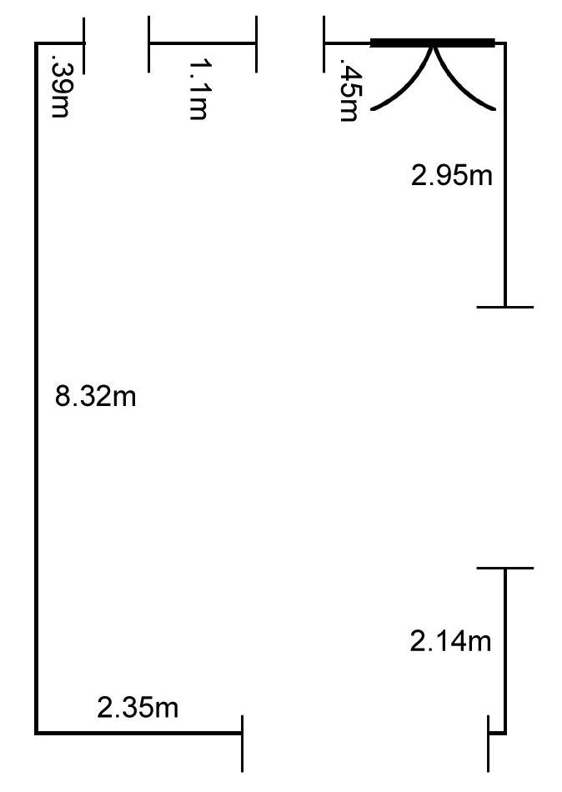

Signed_________________________________Date:___________________
OFFICE USE ONLY
Date received _______________ F Project signature: ______________________

Approved Not approved

